Prediction submission template

NUMERICAL PREDICTION OF DEBRIS FLOW IMPACT FORCES ON SINGLE AND DUAL BARRIERS

Full name of First Team Member¹, Full name of Second Team Member ² and Full name of Third Team Member ³
¹Department of Civil and Environmental Engineering, The Hong Kong University of Science and Technology, Hong Kong SAR, China
²Department of Civil and Environmental Engineering, The Norwegian University of Science and Technology, Trondheim, Norway
³Institute of Mountain Hazards and Environment, Chinese Academy of Sciences, Chengdu, China
This document provides a template for reporting your numerical predictions of debris flow impact forces on single and dual barriers. The report you provide is intended to be only a summary of your predictions, that will allow relatively rapid classification of the type of analysis you performed and compare your predictions with the experimental results. Your report should be as short as possible while providing all of the necessary information.
Two test cases are provided: (1) dual rigid barrier impact and (2) dual flexible barrier impact (https://slope-aoe.hkust.edu.hk/claps-download). Predictors can submit their results for the following four scenarios,
- Impact against single rigid barrier
- Impact against single flexible barrier
- Impact against dual rigid barriers
- Impact against dual flexible barriers
The impact forces and the kinematics for scenarios (I) and (II), please refer to the first barrier configuration in the provided test cases.
The methodology you adopted can be covered by providing appropriate references where possible, rather than writing a lengthy procedure. However, key points should be highlighted if they constitute a novel approach. More detailed explanations may be required if complex constitutive or computational models were used.
1.0 APPROACH TO PREDICTIONS
Scenario | Hand  Calc. | FDM | FEM | SPH | MPM | CFD | DEM | Others
Single rigid barrier
Single flexible barrier
Dual rigid barrier
Dual flexible barrier
For rapid classification of your analysis, please fill in the following table to indicate the method of analysis for your predictions (Only fill the relevant scenarios).
When completing the table, please indicate the name of the software used – e.g. LSDYNA, ABAQUS, Flo3D, PFC, OpenFOAM or bespoke codes developed by the participants. For analytical calculations, please state the name of the method. Leave blank those cells which do not apply to the method of analysis you adopted.
2.0 METHODOLOGY OF NUMERICAL ANALYSIS
Please provide the following information.
- What type of analysis was used and why? See table in Section 1.0 above.
- Indicate whether the analysis is based on small or large deformation theory and why?
- What key assumptions were made in the numerical model?
- Indicate how the interactions of debris flow-with bed, sidewall and barriers are handled? For example, penalty coupling, constrained coupling or any other method.
- What checks were performed, and were convergence studies performed for the numerical analysis?
3.0 CONSTITUTIVE MODEL
Please provide information related to the assumed constitutive behaviour in tabular form. Note that the physical properties of materials in the example table below correspond to materials used in the 28-m flume tests.
Example Table:
Material | Constitutive model | Parameter | Value | Source | Remarks
Debris | Drucker-Prager | Bulk density | 2130 kg/m³ | From organizer
 |  | Cohesion | 0 | Assumed | Granular debris material
 |  | Internal friction angle | 15° | Kwan et al. (2019) | Based on PSD
Steel (Rigid barrier, flexible barrier, bed) | Elastic | Young’s modulus | 210 GPa
 |  | Poisson’s ratio | 0.3
 |  | Mass density | 7870 kg/m³
Aluminum (Rigid barrier) | Elastic | Young’s modulus | 68.9 GPa
 |  | Poisson’s ratio | 0.33
 |  | Mass density | 2700 kg/m³
Concrete (Runout pad) | Elastic | Young’s modulus | 30 GPa
 |  | Poisson’s ratio | 0.2
 |  | Mass density | 2400 kg/m³
Please provide a brief discussion of the rationale for the choices listed above.

4.0 RESULTS
Debris flow impact force predictions will be compared with data from the instruments provided in the following table. The locations of each “Instrumentation cell” is indicated in the download file “Debris impact test cases”.
Please indicate which instruments have been used in each prediction to facilitate comparisons with data. We request that results of your predictions are provided in an Excel, csv or txt file for ease of comparison with measurements.

Description | Units | Value
Total simulation time | s
Instrumentation CELL 1
Flow depth | m
Flow front velocity | m/s
Basal normal force | kN
Basal shear force | kN
Basal pore water pressure | kPa
Instrumentation CELL 2
Flow depth | m
Flow front velocity | m/s
Basal normal force | kN
Basal pore water pressure | kPa
Instrumentation CELL 3
Flow depth | m
Flow front velocity | m/s
Basal normal force | kN
Basal pore water pressure | kPa
Instrumentation CELL 4
Flow depth | m
Flow front velocity | m/s
Basal normal force | kN
Basal pore water pressure | kPa
Instrumentation CELL 5
Flow depth | m
Flow front velocity | m/s
Basal normal force | kN
Basal pore water pressure | kPa

Description | Units | Value
Single rigid barrier setup
Total flow duration | s
Peak impact force | kN
Maximum runup height* | m
Single flexible barrier setup
Total flow duration | s
Peak impact force | kN
Maximum runup height* | m
Maximum barrier deflection* | m
Dual rigid barrier setup
Total flow duration | s
First rigid barrier
Peak impact force | kN
Maximum runup height* | m
Maximum overflow distance* | m
Flow front landing angle* | º
Debris retained behind barrier | m³
Second rigid barrier
Peak impact force | kN
Maximum runup height* | m
Dual flexible barrier setup
Total flow duration | s
First flexible barrier
Peak impact force | kN
Maximum runup height* | m
Maximum overflow distance* | m
Landing angle* | º
Debris retained behind barrier | m³
Maximum barrier deflection* | m
Second flexible barrier
Peak impact force | kN
Maximum runup height* | m
Provide the detailed images for flow kinematics at the barrier impact at 0.5 s interval between 0 s and 2 s (given that flow impacts the barrier at t = 0 s).

Participants are encouraged to add other relevant information in addition to these.

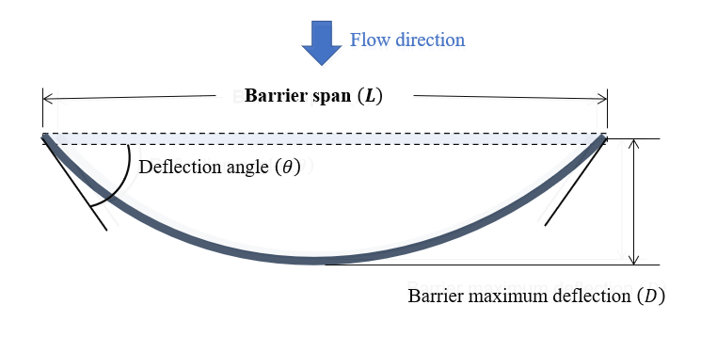
*The schematics are provided below,
Figure 1: Plan view of a deflected flexible barrier

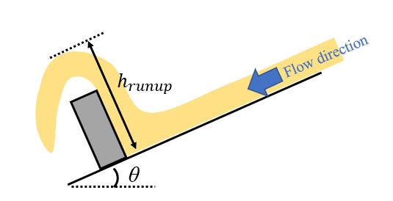
Figure 2: Side view of the flow interaction with a barrier ($h_{runup}$ is the runup height of the flow and $θ$ is the flume inclination)

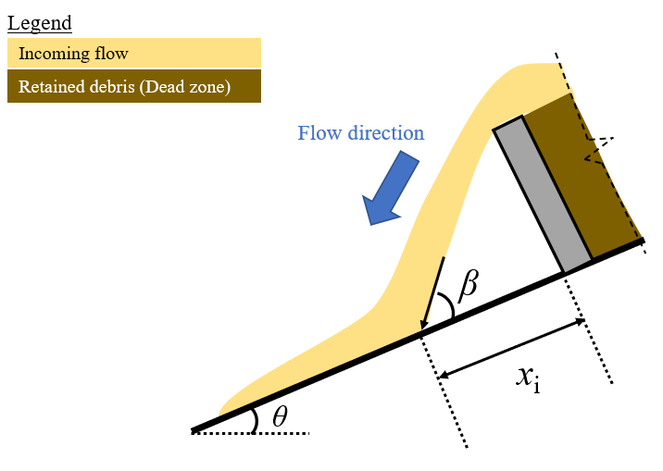
Figure 3: Side view of the flow interaction at landing after the first barrier ($β$ is the flow front landing angle, $x_{i}$ is the overflow distance and $θ$ is the flume inclination)

References
Kwan, J.S., Sze, E.H. and Lam, C. (2019) Finite element analysis for rockfall and debris flow mitigation works. Canadian Geotechnical Journal, 56(9): 1225-1250.

